Rate of Perceived Exertion

Physical and Health Education, Grades 7-9

By Josh Ogilvie

Overview
I use this lesson at the beginning of the year. It gives students ample time to develop and refine their knowledge, as well as their ability to self-monitor and adjust their physical exertion levels.
Throughout the year, students will have the opportunity to demonstrate various methods to achieve their desired levels of physical exertion based on the type of physical activity they are participating in.
As students learn about the various health benefits associated with active living, and about those related to different levels of physical exertion, they will have the opportunity to explore and reflect on their own efforts both in and out of school.

Prior knowledge
Before beginning these learning activities, it would be helpful for students to know/do/understand the following:
- Difference between the health components of fitness (Know)
- Participate daily in physical activity designed to enhance and maintain health components of fitness (D0)
- Physical literacy and fitness contribute to our success in and enjoyment of physical activity (Understand)
- Training principles to enhance personal fitness levels, including the FITT principle and the SAID principle (Know)
- How to participate in different types of physical activities, including individual and dual activities, rhythmic activities, and games (Know)

Big Idea
- Daily participation in different types of physical activity influences our physical literacy and personal health and fitness goals.

Curricular Competencies
- Apply methods of monitoring and adjusting exertion levels in physical activity
- Describe how students’ participation in physical activities at school, at home, and in the community can influence their health and fitness

Content
- Ways to monitor and adjust physical exertion levels
- Effects of different types of physical activity on the body

Core Competencies

Communication
- Explain/recount and reflect on experiences and accomplishments

Critical Thinking
  - Analyze and critique

First Peoples Principles of Learning
  - Learning ultimately supports the well-being of the self, the family, the community, the land, the spirits, and the ancestors.
  - Learning is holistic, reflexive, reflective, experiential, and relational (focused on connectedness, on reciprocal relationships, and a sense of place).

Materials and technologies
Although not necessary, the following technological devices can help support student learning in this activity:
- heart rate monitors
- activity monitors
- various smart phone apps

Learning activities
Class begins with a discussion of the relationship between effort and physical exertion levels in different types of physical activities. Some questions might include:
  - What does your body feel like when you are moving at your fastest pace? Think of your breathing, how warm you might feel, and so on. Compare this to how you’re feeling right now during this discussion.
  - What does your body feel like when you are moving at a “medium” pace, or a pace that is somewhat challenging, but not too hard?

Understanding exertion levels
Use a chart like the one below and student language to help create a common understanding of what the different levels of exertion look and feel like. Start recording some of the descriptors students give for each exertion level.
Rate of Perceived Exertion (RPE Scale)
1 | 2 | 3 | 4 | 5
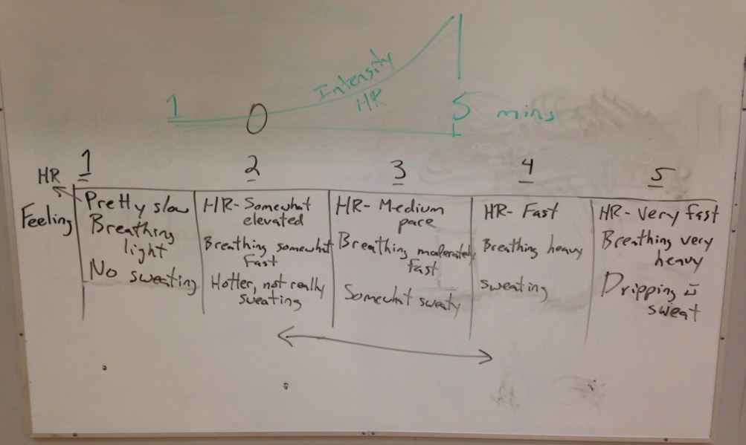
Continue the activity by asking these questions:
- What are some examples of activities where you would be going at:
  - your fastest pace?
  - your medium pace?
  - your slow pace?
- What are some examples of physical activities where you would be moving at these paces?

Warm up
Students choose a desired target zone and begin to engage in a five-minute warm up activity. They use the RPE scale to self-monitor and/or adjust their effort levels to achieve their desired target zone.

Using the RPE scale
The intent of using the RPE scale in the warm up is for students to participate in the activity and use the descriptors to explain what zone or zones they are in at the end of the warm up. For example, “My heart rate is between ‘somewhat elevated and moderately elevated,’ so I’m between zone 2 and 3).
- Ask students to self-assess where they were on the RPE scale and what they might do differently if they were not in their target zone.

Group-based game
After the warm up, students participate in a group-based game in which they are assigned a target RPE zone (e.g., zone 3).
- As students play the game, speak to individual students about which RPE zone they think they are in and what makes them think so. As well, ask what they might consider doing if they were above or below the desired RPE zone.
- Put paper signs numbered 1-5 on a wall. At the end of the game, ask students to stand at the number they feel best represents how they are feeling.
- Conduct a class discussion about which factors helped students get into and stay in the target RPE zone, and which factors might have contributed to not being able to achieve it.

Choosing an activity to maintain an RPE zone
Assign students an RPE zone and a specific amount of time in which to achieve and stay in it. Explain to students they must choose a physical activity that they feel will help them stay in the target RPE zone.
- Activities could be done in the gym, out on the field, in the courtyard, or at other facilities and venues that are available and appropriate.
- Stand back and watch what students are doing and then speak with them individually about their choice of activity, what zone they felt they were in, what they were doing to arrive at and stay in the zone, or what they might have to do if they were not in the RPE zone.

Closing group discussion
Give students the opportunity to come together and explain what they did, how it went, and what strategies they implemented (or might implement) to reach the desired RPE zone.
Closing questions for students might include:
- Were you able to get yourself in the desired RPE zone with the activity you chose to participate in?
  - If so, what helped you do this?
  - If not, why do you think this happened?
- Brainstorm: What do you think are some health and/or fitness benefits from participating in the activity you chose? What about the other activities going on in the class? Create a brainstorm map of these.
- Where can you go to participate in the activities from the brainstorm map?

Reflection questions
The following questions could be given to students to complete in their journals (if using) and/or to open a group discussion for the next class:
- How was your enjoyment of the activity you chose influenced by your level of physical exertion?
- List some of your preferred types of physical activities and consider the following questions:
  - Are you able to get yourself to, and stay in, RPE zone 3-5 in these activities?
  - How might the physical activities you listed influence your health and fitness levels?
  - What are some possible barriers to reaching a RPE zone 3-5 in your preferred physical activities, and what might you do about them?
- In your own words, explain why it is important to self-monitor your individual exertion levels during physical activities.

Goal setting
What fitness goals can you set based on what you’ve learned? (This is about setting personal goals and to improve and/or maintain fitness levels.)

Assessment considerations
Activity | Assessment Considerations
Warm up | Students explain/recount and reflect on experiences and accomplishments.
Using the RPE Scale | Students are able to define the five stages of the RPE scale, and apply this scale.
Group-based game | Students explain/recount and reflect on experiences and accomplishments.
Closing group discussion | Students explain/recount and reflect on experiences and accomplishments.
Self-reflection | Students reflect on how participation in physical activities at school, at home, and in the community can influence their health and fitness.
Goal setting | Students set a personal fitness goal.

Possible extensions of learning
This learning activity can help create a preliminary understanding of the relationship between physical exertion levels and the many health benefits associated with physical activity. You could extend this learning to help students know, do, and understand the following.
Big Idea: Physical literacy and fitness contribute to our success in and enjoyment of physical activity.
Curricular Competencies:  - Participate daily in physical activity designed to enhance and maintain health components of fitness  - Identify and apply strategies to pursue personal healthy-living goals  - Reflect on outcomes of personal healthy-living goals and assess strategies used | Content:  - How to participate in different types of physical activities, including individual and dual activities, rhythmic activities, and games  - training principles to enhance personal fitness levels, including the FITT principle, SAID principle, and specificity

Additionally, having students explore their physical exertion levels in various physical activities can help them embark on a personal inquiry into their beliefs, ideals, and values around physical activity. Some possible questions to get students thinking could include:
- What are some characteristics that make physical activity enjoyable for me?
- What types of physical activities do I prefer and why?
- How are my physical activity levels influencing my health?

