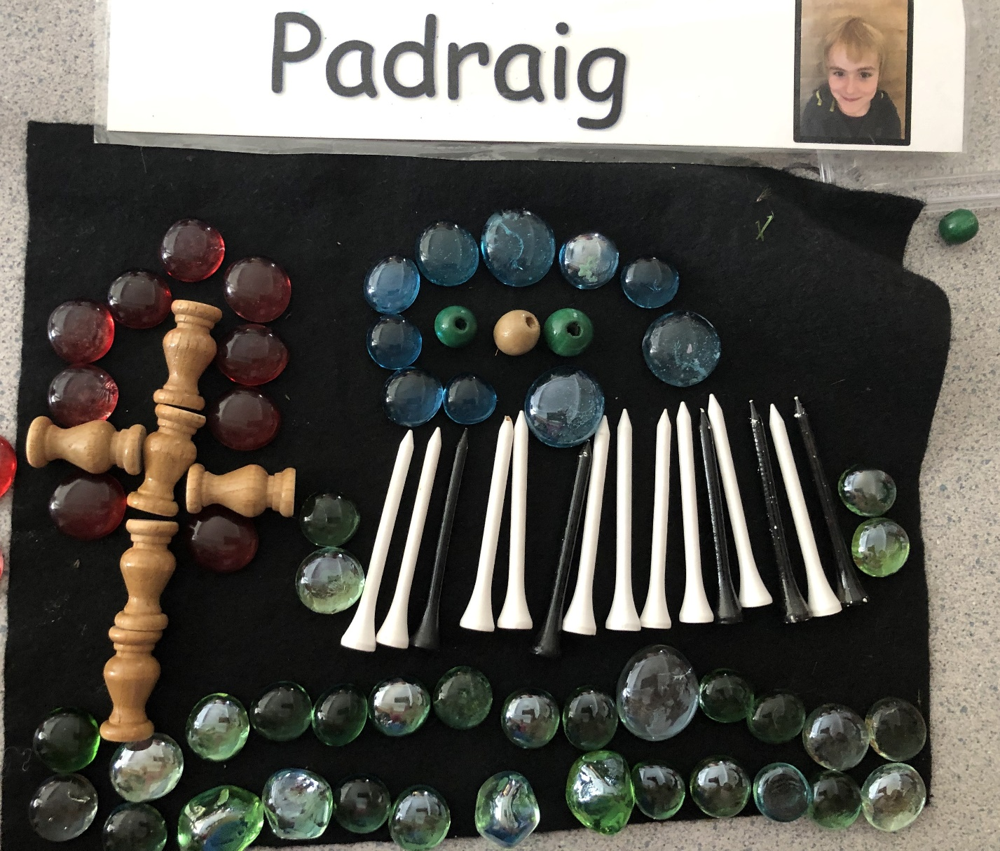

“The beads in the middle are the male and female ducks. The green ones are the males, the brown beads is female. There’s a cherry blossom I saw and those are the bushes.”

