Ethnobotany

Environmental Science 11
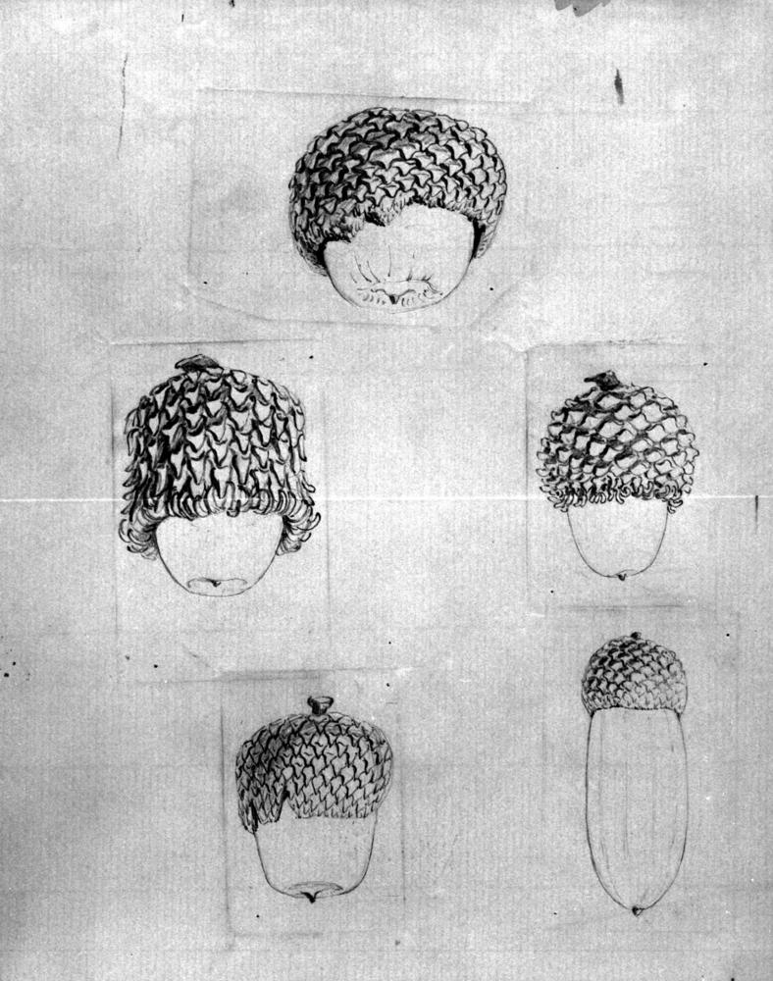
Garry Oak acorns
Crease, Sarah
Date: 185-
http://search-bcarchives.royalbcmuseum.bc.ca:80/botanical-acorns
PDP04657

Grade Level
Grade 11 Environmental Science, with some application in Science 10

Cross-Curricular
Social Studies 10

Description
In this learning experience, students practice ethnobotany. They choose a native plant to study, explore its traditional uses and inquire into ways in which the plant may be restored. Students may also explore sustainable practices that could ensure the plants continued
use in the future.

Environmental Science 11 Learning Standards

Environmental Science 11 Curricular Competencies
- Experience and interpret the local environment
- In this learning experience, students go into the field to see, touch, smell and otherwise experience local plants in their habitat that had significance or special uses for First Peoples.
- Apply First Peoples perspectives and knowledge, other ways of knowing, and local knowledge as sources of information; Analyze cause-and-effect relationships; Use knowledge of scientific concepts to draw conclusions that are consistent with evidence
- Students question what type of human activities an ecosystem in their local area has sustained over the years and what impact human activity has on the species health and continued use.
- Consider social, ethical, and environmental implications of the findings from their own and others’ investigations; Assess risks in the context of personal safety and social responsibility; Contribute to care for self, others, community, and the world through individual or collaborative approaches
- Students consider the evidence for a sustainability approach that they propose, weighing the risk to the ecosystem and the social responsibility to ensure continued traditional use of a plant.

What Environmental Science 11 content is included in
this learning experience?
The activities within the focus on Environmental Science 11 content:
- Ethnobotany in BC concerns First Peoples knowledge and other traditional ecological knowledge, ecosystem complexity
- First Peoples knowledge and other traditional ecological knowledge in sustaining biodiversity
As students assess the threat to the species, they choose to examine and determine what would help the plant survive given current human/environmental actions. Students will describe human actions and their impact on ecosystem integrity, and consider how natural selection and selection pressure plays a role in the plant’s adaptation or extinction. Students will also determine whether invasive species are impacting the plant.
As they consider how to sustain the plant and its human uses in the future, students practice stewardship. They will discover what is required for sustainable use of local resources, and learn about restoration practices required to bring back lost or at-risk resources.

Big Ideas
- Human practices affect the sustainability of ecosystems.
- Humans can play a role in stewardship and restoration of ecosystems.

Science 10 Application
Science 10 students may complete the initial activity in this experience to examine:
- the diversity of plants in the local area,
- the First Peoples’ uses, and
- appropriate choices for including local plants in a school garden.
This activity supports the Science 10 curricular competency to apply First Peoples’ perspectives and knowledge.
Key Questions for Science 10 Application (from Elaborations):
- How has the diversity of plants in your local area benefited
First Peoples?
- How are First Peoples traditional medicines prepared in your
local area?
- How would you safely determine the efficacy of a First Peoples traditional medicine? (Study chemical changes observed, etc.)
- How are First Peoples traditional medicines prepared for
different uses?
- How would you design a garden for your school that features local plants and considers appropriate plant choices?

Cross-Curricular Connections: Social Studies 10 and 11
In this learning experience, students have the opportunity to practice Social Studies curricular competencies as they assess significance, use their inquiry processes and skills, and talk about different perspectives. As they study their chosen plant’s uses over time, students also practice cause and consequence historical thinking by reflecting on environment-human interactions and compare and contrast continuities and changes. They also assess short-term and long-term consequences of human actions in the region where their plant was traditionally harvested and used. The following learning standards apply to Ethnobotany activities.

Curricular Competencies
- Assess the significance of a traditional use of a native plant
in your region
- Compare and contrast continuity and changes—how is this plant
used now? Or is it used now?
- How can our actions influence the continued use of significant species?
What impact do political–economic ideologies have on humans’ relationships with land?

Content
- Human–environment interaction
- Environmental policies affecting land and resources: conflicts
with resource management and supply, conflicts with land use
and ownership (e.g., First Peoples and the concept of land use)
- Climate change—risks, and what environmental policies will
mitigate the loss of the species due to climate change?
- Colonialism and contemporary issues for indigenous people in
Canada and around the world (adapted from Contemporary
Indigenous Studies 12)
- Natural resource use and local, regional, national, or global development (adapted from Human Geography 12)

FPPL Connections
Learning ultimately supports the well-being of the self, the family, the community, the land, the spirits, and the ancestors.
“…ultimately, the primary purpose of learning is for well-being…”
The students’ own natural environment is the starting place for learning about:
- the historical and present-day uses of plants,
- how they contribute to the well-being of the land and the people who live on that land, and
- the social implications of human-environment interaction.
The learning throughout is tied to place.

Prior Learning
Before beginning the activity of the learning experience, it may help to introduce
the relevant vocabulary and model the inquiry process with a sample plant.

Vocabulary
What is Ethnobotany?
The scientific study of the relationship between plants and human cultures in the
past or present.
What do ethnobotanists do?
These scientists study the traditional knowledge and customs of a people concerning plants and their medical, religious, and other uses. These scientists study how people or a culture in a region use the plants of that region to make food, medicine, shelter, or clothing. They do fieldwork and work in a lab, compile statistics, and share their findings.
What is the difference between native and non-native plants?
Native plants are species that are indigenous to the area in a period of geographical time. Non-native plants may also be called an introduced species, or alien species. If the non-native plant spreads beyond the site where it’s introduced, it’s called an invasive species.
What are zones, and what do they have to do with native and non-native plants?
You may wish to review the different regions in the province. You could have students look at hardiness zones, and use that as a guide for finding species that thrive in their region. Then they would investigate whether the species is native or non-native.
Discuss the interrelated nature of ecosystems, referring to any you have studied already.
Before or during the field visit, facilitate a discussion about changes to the availability of certain native produce or trees in your region, and whether any human-environment interaction may be the root cause of those changes. Has climate change or human modification of the geography changed? How, why or where can a particular plant be found or no longer found? Model the investigation on one local species of traditionally used plant. For example, a class in northern British Columbia may discuss the impact of the recently increased size of wildfires on Boreal forest berry plants. Indigenous peoples had practiced landscape burning to increase berry production—what would the consequence be of the massive wildfires the province is now experiencing?

Part One: Research
How are plants used by First Peoples in your local area?
- Go into the field! Experiential learning is an important value of Indigenous culture. Find a site with plants that featured significantly in traditional food preparation, shelter building, clothing or another object making, or medicine. Have students observe the place, record their observations, and reflect on their relationship to the plants of that region.
- (See the Resources section for links regarding traditional plant use in British Columbia. Look for resources related directly to your region. Your local library or regional museum may be of help.)
- Select a plant from your region that humans use in some way now or have in the past. Choose a species that is native to your region, rather than a non-native plant. Don’t forget ocean plants if you live in a coastal area.
- Ask students to reflect and investigate: Do your chosen species have any associations for you? If so, what are those? How is it used now? Do you currently use the plant for food, medicine, or in building homes?
- Option: If a student comes from a different region in British Columbia and wishes to study a plant from that region, they could focus on a species from their home environment.
NOTE: Before they contact an Indigenous person to talk about their species, ensure students understand how to contact First Peoples respectfully to ask about their cultural practices.
- Ask students: How could you find out about this plant’s uses before the present day? Look for ideas that include any of the following:
- Speak to an Indigenous Elder or Traditional Knowledge Keeper or Healer.
- Research in the library: Check out books and encyclopaedias
- Ask someone in your family
- Research on the internet
- Interview a park naturalist or botanist
- Ask parents and grandparents how they used the plant when they were younger.
- Look to traditional place names. Ecological knowledge of plants is encoded in First Peoples’ languages. Are there place names or stories from the region that communicate knowledge about the resource and its use?
- Explain that what they have just done is what ethnobotanists do.
- You may wish to show the video interviews with ethnobotanist Dr. Nancy Turner.

Teachings of Respect
Dr. Nancy Turner, Ethnobotanist, on land, seasonal round harvesting, connection with land, canoe bark, the health of people in symbiosis with the health of land.
https://media.openschool.bc.ca/osbcmedia/fns12/video/fn121intro1v_ntrespect_m.mp4

Sandbar Willow Syndrome
Dr. Nancy Turner introducing grand fir and reflecting on the loss of species/loss
of knowledge (sandbar willow syndrome). Facilitate a discussion with students.
https://media.openschool.bc.ca/osbcmedia/fns12/video/fn1243a1v_ntwillow_m.mp4

Video Guided Inquiry
What was the result of this consistent perspective as Dr. Turner discussed? How did this perspective benefit both the people and the land on which they relied? What has changed, or stayed the same?
Dr. Turner mentions kinship with other life forms. Consider the perspectives in the canoe builder talking to the tree, and the other plants around it, to communicate with it. How does this belief system help the land and the people thrive together? Compare this with other belief systems present in the region. How would they influence the environment-human interaction? For the better, or worse?
Consider the perspectives of loggers, settler foresters, developers, settler environmentalists. What might their perspective be?
NOTE : This is a cross-curricular approach. Social Studies competencies may be used to infer and explain different perspectives.
Harvesting of cedar bark—why would the tree be killed if all the bark was removed? This is an example of sustainability practice in the human use of a local resource. Are there others that you are aware of from class discussion and your research?

Part Two: Share Your Findings
What is important to know about your species?
- Students select and communicate a short description of their chosen species and its features (video, oral presentation, written presentation, infographic, etc.). Encourage students to bring in a sample of a chosen plant to share during a class. Ensure they practice good stewardship when collecting
native plants.
How to collect samples
- Collect small amounts of material in a sensitive manner, to ensure propagation and food and habitat for wildlife.
- For live, whole-plant samples, check nurseries or garden centres.
- Do not remove plants from a park or other protected area.
They should consider the following questions as they decide what to share now that they have found out about their species:
- How has this plant adapted to its habitat and climate?
- Is this plant species essential to the well being of First Peoples now or in
the past?
- Was your species used as food historically? If no, why not? If yes, how was
it traditionally prepared and enjoyed?
- What happens if the language that is traditionally used to pass on information about a species is lost?
- Was it used as medicine? If so, how was it used, and for what ailments? How are traditional medicines prepared in your local area? What local protocols need to be considered? Is this plant species now endangered in your area?
If so, how could it be restored or protected?

Core Competencies
Communication
Students develop this competency as they present information related to their chosen species in a clear and organized way, taking information from complex and specialized information sources.
Social Awareness and Responsibility
Students develop this competency as they consider and plan for sustainability practices that benefit the community that has used their plant resource.
Video Connection
In the Ethnobotony videos you watched, Dr. Turner talked about how traditional knowledge transfer may change, but the desire to live in harmony with the land and the species continues. Do you see the knowledge transfer about native plants in your community being carried out in a new way?
What stewardship practices are needed now?
- Have students assess the threat, if any, to their chosen species. For plants at risk, determine what would help the plant and its uses survive today’s human/environmental interactions. If the species is nearly extinct, how could it be restored? Would its restoration also succeed in reviving its traditional use? If the restoration effort was made, would another factor such as “Sandbar Willow Syndrome” inhibit the continuation of traditional use? Dr. Turner found this with her suggestion for helping regrow the sandbar willow: it may succeed, but the lack of knowledge transfer means that hardly anyone knows how to make the baskets.
- What evidence can you give that your proposed stewardship or restoration practice would meet with success?
- Consider the impact of any restoration effort you propose. Would the re-establishment of this (or another) species have an effect on other life in the ecosystem now? If so, what would that impact be?
- What do we lose if we don’t record the uses and benefits of native plant species? How would your findings help you advocate for the importance of the biodiversity of a local area? Could you take your presentation and share your findings of your species and the human impact with a local community group? How might it motivate others to reduce human activity that negatively impacts the species and its use?

Assessment
You may use the following as a summative assessment for student presentations on the chosen plant. If you wish to have students submit drafts of their presentations for teacher or peer feedback before presentation day, the form could also be
used as a formative assessment to guide the student’s final revision. The same form may also be used to provide a summative assessment on presentation day.
What Needs Improvement? | Criteria  Standards for Performance | How does the work exceed expectations?
Research
Student’s research accurately discovers the uses of the plant in the past and present.
Processing and Analyzing Information
Student shows an ability to connect the prior and present uses to the significance of the plant species.

Student has considered the impact of different worldviews on the use of the species. Also to be considered is the species’ ability to thrive in the region and continue to benefit. Or have these worldviews put the species at risk? (Especially for Social Studies use - How can our actions influence the continued use of significant species? What impact do political–economic ideologies have on humans’ relationships with the land?)

Student can experience and interpret the local environment, applying First Peoples perspectives and knowledge.

Evaluating

Student has thought through the interconnection of life in the ecosystem and can make predictions about the effects of different efforts.

Student shows awareness of the likely outcomes of the loss of a species.

Student considers social, ethical, and environmental implications of the findings from their own and others’ investigations. (Note how they respond to peer presentations, and in a discussion.)

Applying and innovating
Student contributes to finding a solution to sustain native plants with traditional uses.

Extensions
If a student shows interest in their sustainability or restoration ideas, consider assigning them a follow-up project to share their ideas with a community group who has an influence on the ecosystem.
If Visual Arts is an interest, offer students a cross-curricular option and have them
sketch their sample, and present information about the history of botanical drawings.
For further inquiry for Social Studies students, or Environmental Science students particularly interested in the historical practices in the ecosystem: Investigate how
settler families learned about local plants and their uses from indigenous people. How
was that knowledge passed on? What changed or stayed the same in the transfer of
that knowledge?

Core Competency Self-Reflection
You may provide the following questions to students for self-reflection on their participation in the Ethnobotany activities.
- How did I share and learn from others?
- How did I use my knowledge about how ecosystems function?
- Did I present my findings in a clear way that could be understood by others?
Or provide the following checklist before the activity as a set of targets, or after as a check-in on their participation.
- I used open-ended questions that gathered information about my
chosen species
- I applied knowledge of the interrelatedness of life in an ecosystem. I made predictions about how my plant’s continued presence or its absence would affect humans and other life in the region
- I communicated the knowledge I gained in a straight-forward way. I presented the core information and contributed to the group’s discussion of native species in our habitat. I explained how First Peoples’ perspectives and local sources of knowledge could help the scientific study that benefits us, physically, and culturally.

Teacher Feedback
Teachers support student learning by providing feedback on areas of proficiency and making suggestions to help extend learning. Ongoing feedback supports skill development and refinement. When the teacher provides feedback both to individuals and to the class, targeting common challenges, and questions students, this promotes deeper thinking.

Teacher Self-reflection
- What were the strengths of this project?
- How has this project helped my students to develop the curricular competencies and their understanding of the Big Ideas?
- What do I want to do differently next time?

Resources
The following are examples of videos or lessons that support learning in this area.
Wild edible and medicinal plants of British Columbia
Brief history and overview of some of the main edible and medicinal plants
used by BC First Nations
https://en.wikipedia.org/wiki/Wild_edible_and_medicinal_plants_of_British_Columbia
Nancy Turner’s website
Bio, publications, and projects by Nancy Turner, the ethnobotanist featured
in the lesson’s video interviews
http://pspaldin.wixsite.com/nancyturner
RBCM’s Learning Portal Pathway: Native Plants on the South Coast
A collection of articles, video, and photos of south coast native plants.
http://learning.royalbcmuseum.bc.ca/pathways/native-plants-south-coast/
Traditional Food Facts Sheets
PDF with information about many types of traditionally hunted, fished, and
gathered foods in BC
http://www.fnhc.ca/pdf/Traditional_Food_Facts_Sheets.pdf
Traditional Plant Foods of Canadian Indigenous Peoples: Nutrition,
Botany, and Use by Harriet V. Kuhnlein and Nancy J. Turner
A book describing and referencing the published literature on properties
and uses of traditional food plants of Canadian Indigenous Peoples
http://www.fao.org/wairdocs/other/ai215e/AI215E00.htm

