Je vous présente un monstre – Meet a Monster
Late French Immersion Grade 6

By Ellen Bornowsky

Overview
This project encourages students who are in the initial stages of acquiring French vocabulary and linguistic structures to use them in a creative and personalized way. Once the profiles have been created, students circulate around the room in a “meet & greet” activity where the monsters interview one another. This activity supports the goal of using French for self-expression and authentic communication.

Big Ideas
- Words shape our thoughts; a more extensive vocabulary enriches thinking skills.
- The ability to communicate in a new language improves as we take risks in that language.
Curricular Competencies  - Exploring & Reflecting: Identify the structure of a sentence by identifying word groups within it.  - Creating & Communicating: Read a text, articulating & pronouncing the words correctly. Express & justify an opinion on a familiar theme | Content  - Elements of a story: characters, settings, events  - Spelling conventions  - Language elements: simple linking words, sentence structure, parts of speech, verbs in the present tense

Core Competencies
- Communication: connect and engage with others to share and develop ideas
- Thinking: generating ideas, developing ideas

The Learning Experience
Students were given opportunities to brainstorm and generate ideas about the potential physical characteristics and personality traits of monsters based on their own experiences with popular culture (literature and movies.)

Students were given a project information sheet (attached) with simple structures and sample sentences to use as a model. Students were encouraged to adapt the pattern sentences to ensure their work would be grammatically correct, rather writing in English first and than using an online translation tool.

Students engaged in the writing process by writing drafts and peer editing. Students were given a choice of materials to create a visual representation of their monster (modeling clay, paper, coloured pencils, materials).

Once the descriptions and visual representations were completed, students worked in small groups to practise asking and answering questions to share personal information about their classmates’ monsters.

Integration of Technology
Students could use iPads with an app like Chatterpix to create an image and record the description. Students could use a voice recorder to practise, monitor and self-correct their oral language (fluency, pronunciation, intonation, grammatical accuracy).

Differentiation
Many students are able to generate a variety of ideas independently, while others require support in the form of sharing, researching and interacting with peers. Students who are concrete sequential learners and unable to generate ideas independently can use the model provided to practise and demonstrate their learning. The scope of the assignment (amount of detail, length of description) can be varied to accommodate a wide range of learners.

Extension
The activity could be extended to have students create a profile of a classmate, family member, historical or contemporary figure or a fictional character, celebrity, personal hero or idol.

Possible Assessment Strategies

Skills Checklist (Process) not yet with support by myself
I can listen respectfully to classmates
I can share materials
I can use materials without wasting
I can ask for assistance
I can respond appropriately
I can provide constructive feedback
I can communicate with classmates in French
I can communicate with teacher in French

Product
figure/model/illustration – attention to detail, careful craftsmanship, evidence of effort
descriptive paragraph – written work incorporates target vocabulary & grammatical structures

Performance
interview (Listening Comprehension & Spoken interaction)
spoken interaction incorporates target vocabulary & grammatical structures,
speech is natural, relaxed & fluent with native-like accent & intonation

monstre projet – planification

je me présente
(une description personnelle en phrases completes)

Salut!
name
age
town
height
glasses*
eyes
hair
2 adjectives (and = et)
hobby #1
hobby #2
hobby #3

I like…
I don’t like …
I love/hate …

*only if you wear glasses

monstre projet

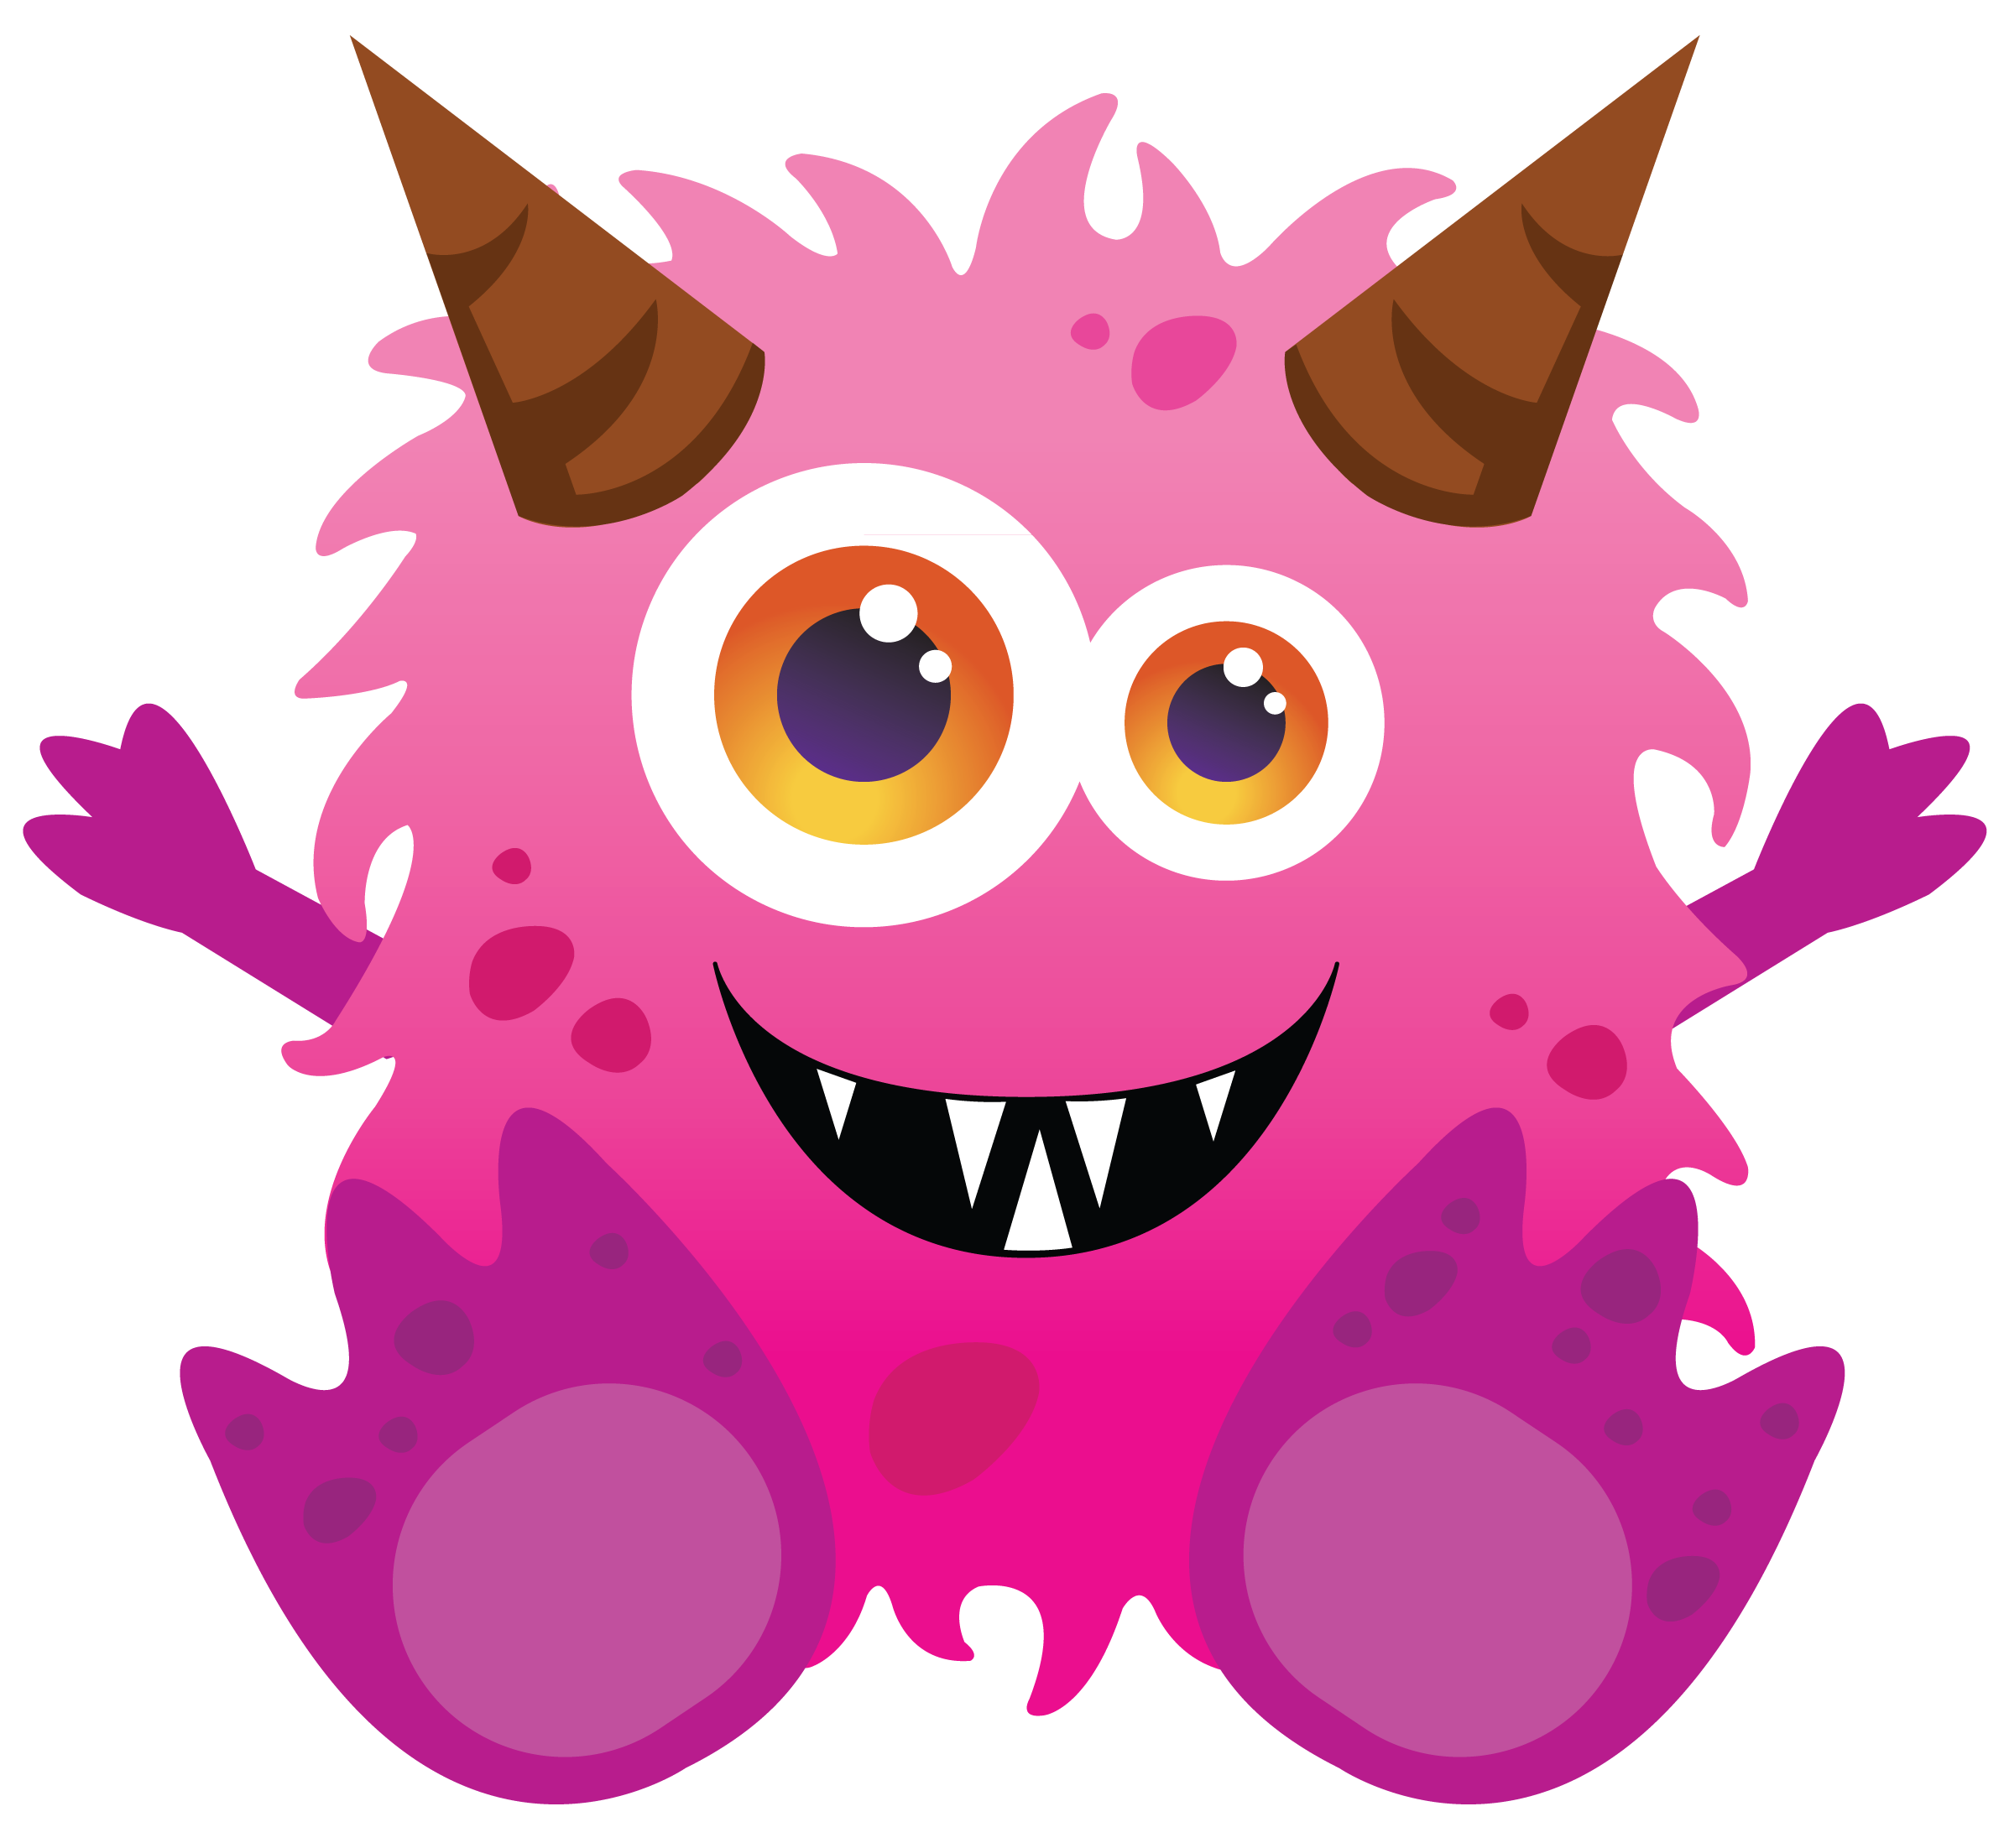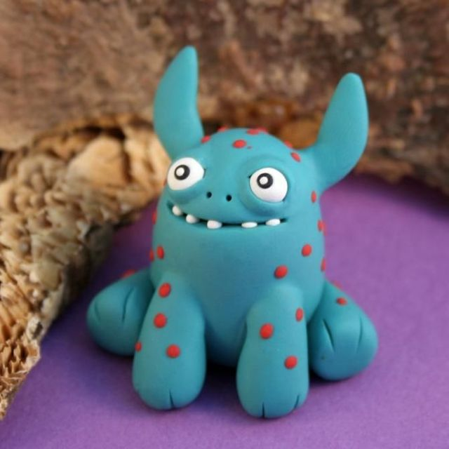

je me présente
Salut!
name Je m’appelle Gronk
age J’ai treize ans.
town J’habite à Monstreville.
height Je suis de taille moyenne.
glasses* Je porte des lunettes.
eyes J’ai les yeux roux.
hair J’ai les cheveux bruns et longues et bouclés.
2 adjectives Je suis amusant et sportif. Je ne suis pas musicale.
hobby #1 Je fais de la natation.
hobby #2 Je fais aussi de la planche à roulettes.
hobby #3 Je fais de la danse aérobique.

I like… J’aime les hotdogs et la pizza.
I don’t like … Je n’aime pas les salades et le café.
I love/hate … J’adore la couleur noire et je déteste les serpents.

*only if you wear glasses

le monstre se présente

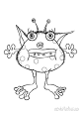

je me présente
Salut!
name Je m’appelle Gronk
age J’ai treize ans.
town J’habite à Monstreville.
height Je suis grand.
eyes J’ai les yeux bleus.
hair J’ai les cheveux bruns et longues.
2 adjectives Je suis amusant et sportif. Je ne suis pas musicale.
hobby #1 Je joue au baseball et au hockey.
hobby #2 Je fais de la danse.

I like… J’aime les hotdogs et la pizza.
I don’t like … Je n’aime pas les salades et le café.
I love/hate … J’adore la couleur noire et je déteste les serpents.

Le monstre Gronk
Reading Activity

1. How old is Gronk?
2. Where does he live?
3. Is he tall or short?
4. What colour are his eyes?
5. What colour is his hair?
6. How does Gronk describe his personality?
7. Is Gronk musical?
8. What are Gronk’s hobbies?
9. What are Gronk’s favourite foods?
10. Which foods does he dislike?
11. What’s his favourite colour?
12. How does Gronk feel about snakes?

le monstre se présente

Je me présente
version 1
Salut!
name Je m’appelle
age J’ai ans.
town J’habite à
height Je suis
hobby # Je joue au

I like… J’aime
I don’t like … Je n’aime pas
I love/hate … J’adore et je déteste

Je me présente
version 2
Salut!
name Dracula
age 1000
town en Translyvanie
height petit.
2 adjectives intelligent et sportif
hobby hockey.
I like/love… les bonbons et le chocolat.
I hate/detest les carottes et les tomates.

