STORY TILES

Arts Education - Art Studio 10

Rationale
Stories enable us to connect, express emotions, ideas and worldviews. Throughout history, people have shared stories, not just through the oral tradition, but visually as well; pictographs and cave paintings provide us with a window into our collective pasts.
This lesson encourages self-reflection and community building. Using a 4x6 canvas tile, students are challenged to visually depict a profound or defining moment in their lives. Individually, each tile tells a personal story and highlights how we are unique and special. Collectively, the tiles speak to our diverse culture, describe our connections with others, and reveal our similarities and differences. Students grow to appreciate each other through the sharing of these stories and come to realize that we do not live in isolation, but within a supportive community. By actively participating in this lesson, students learn from one another and contribute to a positive school environment. The more opportunities we have
to share our stories, the more we can connect, feel empathy and learn from each other.

Big Ideas
- An artist's intention transforms materials into art.
- Traditions, perspectives, worldviews, and stories are shared through aesthetic experiences.
- Visual arts offer unique ways of exploring our identity and sense of belonging.

Curricular Competencies
Explore and Create
- Explore artistic possibilities and take creative risks
- Express meaning, intent, and emotion through visual art
Reason and Reflect
- Develop personal answers to aesthetic questions

Communicating and Documenting
- Communicate ideas through art making
Connecting and Expanding
- Create artistic works that demonstrate personal, cultural,
and historical contexts

Content
- elements of visual art
- principles of design
- image development strategies
- materials, techniques, and technologies
- creative processes
- use of symbols and metaphors to represent ideas and perspectives

Core Competencies
Communication, Thinking, and Personal and Social Competencies are developed as students work to capture a profound, defining moment in a story tile. Students will develop these Core Competencies as they share and develop ideas, plan and create a story tile that is novel and has value and analyze their own work based on co-created criteria:

Communication
- Communicating
- Connecting and engaging with others
- Acquiring and presenting information
- Collaborating
- Working collectively
- Supporting group interactions

Thinking
- Creative Thinking
- Generating and incubating
- Critical and Reflective Thinking
- Analyzing and critiquing

Personal and Social
- Positive Personal and Cultural Identity
- Recognizing personal values and choices
- Social Awareness and Responsibility
- Building relationships
- Valuing diversity

This lesson is guided by the following First Peoples Principles of Learning
- Learning is holistic, reflexive, reflective, experitential, and relational.
- Learning is embedded in memory, history, and story.
- Learning requires an exploration of one’s identity.

The Lesson
Teachers may begin by introducing the project to students and explaining the rationale.
A story tile is an individual piece of work that will become part of a much larger installation of tiles. This lesson will result in an inventory of important and defining moments in students’ lives; it will tell the group’s story.
The steps to creating a tile
- Explore the essential question: What has been a profound or defining moment in your life? Discuss what is meant by “profound” and “defining”, sharing examples to build understanding and to generate ideas.
- Establishing criteria: Share examples of how students accomplished this assignment in a variety of ways and work together to generate assessment criteria. (Please see sample criteria in the assessment section of this document).
- Brainstorming: Students work in their sketchbooks and brainstorm ideas for their canvases.
- Creating a rough draft: Once they have developed their story/image students will need to select the medium(s) which they feel are best suited to enhance their composition and tell their story, and create a rough draft.
- Interviewing: Students will meet with their teacher to discuss their vision. This is an opportunity for teachers to ask questions that promote deeper thinking and to provide formative feedback on rough drafts that will help inform final pieces.
- Creating final draft: After consulting with their teacher, students will get their canvasses and will create their story tiles.
- Writing an artist statement: Once students have completed their tiles, students develop an artist’s statement describing their process and addressing their intent – what they are aiming to communicate through their story tiles.
Artist Statement: Create an artist statement (1-2 paragraphs) to support your story tile. In your artist statement explain:
- How you created your piece (your artistic process): What medium and techniques did you use?
- What have you created (describe your content): What did you intend to convey to the audience?
- Why you created this image (meaning): Why is this memory meaningful to you?
- What you feel you have learned as a result of this work (your learning): What have you accomplished with this piece of art?
Your statement must be in the first person, everything is “I” not “he/she/they.” Imagine you are having a conversation with a viewer.
- At this point, students share their tiles with the teacher one-on-one, in small groups, or with the class. The class works together to arrange the tiles into a collage, creating a powerful montage representing community. Students are invited to reflect on others’ shared experiences and feelings, and draw meaning from the collective display. By sharing their work and reflecting, students discover new things about themselves and others, and build stronger connections with their peers in the process. (Please see Peer/Class Discussion questions in the assessment section of this document).

Student samples up close
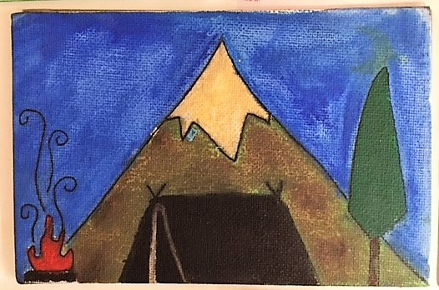
This student’s favourite story is camping with her family. She used watercolour pencil crayons and a fineliner
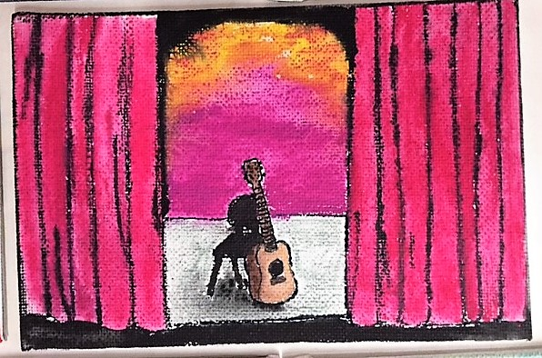
Student depicts a defining moment in his life when he sang for an audience for the first time

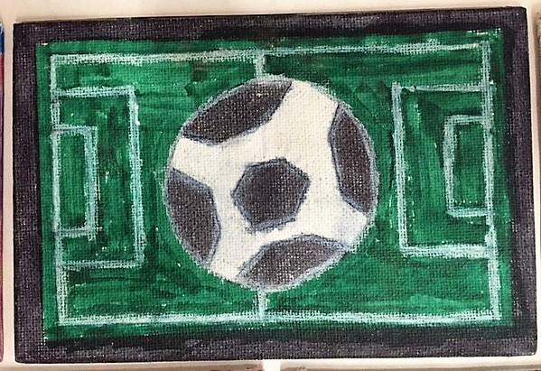
This sample depicts the student’s love for the game of soccer
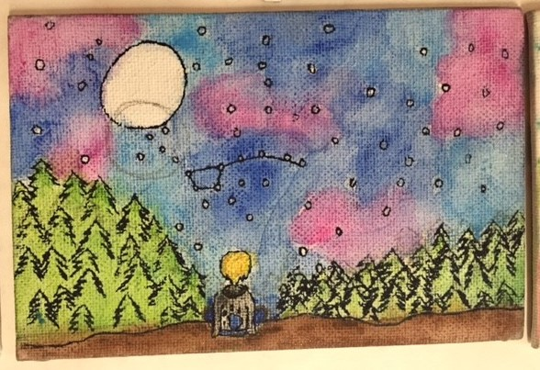
This student depicts a night of camping with her father and learning about the stars

Assessment Options

Engagement
Daily engagement can be tracked by observing and noting how often the student is:
- actively participating in class
- using their time effectively
- challenging/building their abilities by taking risks
- applying new techniques
- showing creative self-expression
- taking ownership and pride in their work and workspace
- using and applying feedback from teacher and/or peers

Peer/Class Discussion as Formative Assessment
Discussions with peers provide opportunities for students to gain insight about themselves as learners and their unique learning processes. The following sample questions can be used to prompt reflection and to support peer and/or class discussions:
- How did you feel about this challenge/project?
- Tell me about this story. Why this story?
- How has this experience influenced your values? What impact does
this experience continue to have on your life today?
- What aspect of your work is most effective?
- What aspect of your work is least effective?
- What was the most challenging?
- What would you do differently next time?
- What actions will improve your work?
- How does this piece compare to your previous work?
- What did you learn about yourself in this process?

Teacher Feedback
Teachers support student learning by providing feedback on areas of proficiency and making suggestions to help extend learning. Throughout the project, the teacher encourages experimentation with media and models proper techniques. As students
work, the teacher provides feedback and questions students to promote deeper thinking, both to individuals and to the class, targeting common challenges. Skill development
and refinement are supported when teachers model and provide direct instruction and ongoing feedback.

Assessment Tool
Students are more likely to engage and put in effort when they have a clear understanding of the goals of the project and how they will be assessed, when they believe the goals and assessment are meaningful, and when they believe they can meet the expectations.
A co-constructed standards-based assessment tool is helpful in guiding students in their work and can be used at the end of a project or assignment to provide feedback on students’ progress in relation to the learning standards (Curricular Competencies and Content) of the curriculum.
Criteria (like the sample criteria below) may be generated collaboratively with students.
Curricular Competencies | Criteria
Express meaning, intent, and emotion through visual art  Communicate ideas through art making | Effectively selects and manipulates art elements, materials, and techniques to express meaning, intent, and emotions
Explore artistic possibilities and take creative risks | Demonstrates an openness to artistic exploration and willingness to take risks  when creating original artwork
Develop personal answers to aesthetic questions  Create artistic works that demonstrate personal, cultural, and historical contexts | Articulates personally meaningful connections to their artistic process and product

In the following application, students are invited to reflect on and provide evidence of their learning in relation to the co-created criteria. Students may use the “My Evidence” box to explain if and how they have met the criteria and the “My Next Steps” section to set personal goals to help them extend their learning. Teachers review student-selected evidence and reflection on next steps and provide strength-based feedback to help guide students in
their learning.

Student Reflection
I effectively selected and manipulated art elements, materials, and techniques to express meaning, intent, and emotions.
My Evidence: | My Next Steps:
I demonstrated an openness to artistic exploration and a willingness to take risks when creating my original artwork.
My Evidence: | My Next Steps:
I was able to communicate my personal connection to this artistic process and product.

My Evidence: | My Next Steps:
Teacher Feedback
Strengths: | Next Steps for Learning:

Teacher Reflection
How has this project helped my students to develop the curricular competencies? Their understanding of the Big Ideas? What were the strengths of this project? What do I want
to do differently next time?

