Design Challenge: Firefighting Supply Robot

Electronics and Robotics, Grade 10
Applied Design, Skills, and Technologies
By Russell Evanisky

Learning goal
Design, build, and program an autonomous supply robot that will transport firefighting materials to a supply drop zone near a forest fire.

Overview
This instructional sample describes a design challenge for building and programming a robot for Electronics and Robotics 10. There are many robotics platforms available, and it is up to teachers to choose a platform and to familiarize themselves with its technology and software and programming language.
In this lesson, students will work collaboratively in groups to investigate the design parameters. Students will analyze the field and obstacles surrounding a supply drop zone and ideate designs for their robot and prototype. Students will program their autonomous robot to navigate around obstacles in the field from the start position to the supply drop zone. The robot must utilize sensors that allow for autonomous navigation and obstacle avoidance.
Groups will design, construct, program, and test robots, and materials will be equally distributed among all groups.

Big Ideas
- User needs and interests drive the design process.
- Social, ethical, and sustainability considerations impact design.
- Complex tasks require the sequencing of skills.

Content
- Design opportunities
- Breadboard circuitry (depending on robot platform type)
- Sequences involved in making a functional robot
- Robot elements (including inputs, outputs, sensors, and motion)
- Block-based coding or logic-based programming for robotics
- Flow charts related to robotics behaviour

Curricular Competencies
The following Curricular Competencies are addressed throughout this lesson.
Applied Design
Understanding context
- Engage in a period of research and empathetic observation
Ideating
- Take creative risks in generating ideas and add to others’ ideas
in ways that enhance them
- Screen ideas against criteria and constraints
- Critically analyze and prioritize competing factors to meet community needs for preferred futures
- Maintain an open mind about potentially viable ideas
Prototyping
- Choose a form for prototyping and develop a plan that includes key stages and resources
- Prototype, making changes to tools, materials, and procedures
as needed
Testing
- Conduct the test, collect and compile data, evaluate data, and decide
on changes
Making
- Identify and use appropriate tools, technologies, materials, and processes
- Use materials in ways that minimize waste
Applied Skills
- Develop competency and proficiency in skills at various levels involving manual dexterity and circuitry
- Identify the skills needed, individually or collaboratively, in relation to specific projects, and develop and refine them
Applied Technologies
- Choose, adapt, and if necessary learn more about appropriate tools and technologies to use for tasks
- Evaluate impacts, including unintended negative consequences, of choices made about technology use
- Evaluate the influences of land, natural resources, and culture on the development and use of tools and technologies

Core Competencies
- Communicating
- Collaborating
- Creative Thinking
- Critical and Reflective Thinking

Learning experience

Research and planning
- Students will conduct research (using newspapers, video, social media posts)
to understand the conditions facing firefighters across B.C. Then, working in pairs or small groups, students will take turns engaging in simulated empathic interviews through role-play. Taking on the firefighters’ perspectives, they will gain deeper understanding of the dangerous and limiting conditions they face on the ground.
- Organize students into collaborative groups. Students will analyze the field
and create a plan-view drawing of the field with accurate measurements of all obstacles and features. Students will need to record any coloured features (such as start and finish areas) and path markings that could assist autonomous navigation of their robots.
Working individually, each student will brainstorm and draw/sketch a minimumof two robot drive-base designs. Student sketches must represent and label the locations of the sensors that will be used for navigation and object avoidance. Designs will include a combination of bump/touch sensors, colour sensors, ultrasonic sensors, distance sensor, and gyros.
The teacher will create a tangible payload that the students will inspect, weigh, and measure. During the evaluation phase, the robot will need to transport and deploy this payload to the designated supply drop zone.
- In groups, students share their ideas, and decide which design and/or combination of designs to build. Students are encouraged to combine the best design elements from multiple ideas to create their robot.
Before the construction of their robots, students will create a flow chart that details basic wall detection and navigation. This flow chart will be used during the programming phase of the project.
- Students will construct the robot chassis, adding the sensors and beginning the programming process. All students will need access to the field for testing and calibration of their robots. Multiple fields are preferable to allow more testing and refinement.
Students will make structural and sensor changes to their robots. (Note that when the robot reaches the supply drop zone, it should also drop off the payload of supplies to the firefighters.) Once they have achieved successful repeatability of their autonomous program, students will let the teacher know that it is ready for observation and evaluation of a successful run.

Assessment considerations

Teacher observation
Teachers will have many opportunities to observe students during the design challenge process. Teachers will be able to provide direct teaching to groups and individualized instruction based on the needs of specific groups and students.
Assessment type | Focus of the assessment | Where to find evidence in the design thinking process
Assessment  FOR Learning | Formative and diagnostic.  Opportunity to provide students with ongoing feedback and provide clarifications to address potential misconceptions | - Student engagement in empathetic interviewing  - Student participation and communication with peers in the group design thinking process  - Student representations of their thinking through their sketches  - Troubleshooting and improving iterations of the robot design
Assessment  OF Learning | Summative  evaluation | - Demonstrations based on success determinants of the design challenge  - Student explanations of decisions to include/exclude the parameters required in the design challenge and/or any deviations  - Student descriptions of understanding related to the Big Ideas, Content, and Curricular Competencies
Assessment  AS Learning | Self and peer reflection | - Student explanations to peers about their designs  - Nature of student questions and engagement as critical friends during peer assessment interactions  - Providing feedback as a critical friend  - Incorporating feedback from peer(s) into the initial and then the team design  - Using peer feedback to improve design and/or process  - Setting personal learning goals related to Curricular and Core Competencies
Source: Taking Making into Classrooms

Self-assessment
“I can” statements: Students reflect on their development of the Core Competencies in the areas of communication, creative thinking, and critical thinking using “I can” statements. For example, the “I can” statements below combine the Curricular Competencies of Electronics and Robotics 10 with these Core Competencies.

Communicating and Collaborating
I can engage in a period of research and empathetic observation. I can connect and engage with others to develop ideas as demonstrated by:
_________________________________________________________________________
I can collaborate on idea generation and maintain an open mind about potentially viable ideas. I can connect and engage with others to share and develop ideas as demonstrated by:
_________________________________________________________________________
I can work effectively both as an individual and collaboratively in a group. I can collaborate to plan, carry out, and review constructions and activities as demonstrated by:
_________________________________________________________________________

Creative thinking
I can take creative risks in generating ideas and add to others’ ideas in ways that enhance them. I demonstrated this creative thinking by:
_________________________________________________________________________

Creative thinking
I can critically analyze and prioritize competing factors to meet community needs for preferred futures. I can analyze and critique as demonstrated by:
_________________________________________________________________________
I can conduct a test, collect and compile data, evaluate data, and decide on changes. I can develop and design as demonstrated by:
_________________________________________________________________________

Peer assessment
Teachers can facilitate peer assessments by creating tools that focus on specific Curricular Competencies and are easy for students to use. For example, see the sample peer assessment tool below.

Teacher feedback
Teachers support student learning by providing feedback on areas of proficiency and making suggestions to help extend learning. Ongoing feedback supports skill development and refinement. When the teacher provides feedback both to individuals and to the class, targeting common challenges, and questions students, this promotes deeper thinking.

Teacher self-reflection
- What were the strengths of this project?
- How has this project helped my students to develop the curricular competencies and their understanding of the Big Ideas?
- What do I want to do differently next time?
- Teacher information: Designing an autonomous robot

Proposed field design
My name_______________ My peer_______________

1. My peer listened carefully and asked relevant questions during the empathetic interview.
Strongly Agree | Agree | Neutral | Disagree | Strongly Agree
2. My peer demonstrated an open mind about the ideas presented by others.
Strongly Agree | Agree | Neutral | Disagree | Strongly Agree
3. My peer generated good ideas and added to others’ ideas in ways that enhanced them.
Strongly Agree | Agree | Neutral | Disagree | Strongly Agree
4. My peer helped to make decisions that were helpful to the group.
Strongly Agree | Agree | Neutral | Disagree | Strongly Agree
Comments and examples:

The teacher creates a robot field perimeter using a 4’ x 8’ sheet of plywood. The perimeter must include walls to prevent the robot from falling off the field and on to the floor. The robot sensors will be utilized by the walls.
The field design should incorporate the following:
- One dead-end obstacle
- Trees
- Hill
- Fallen log

Required materials for the field:
- Field driving surface suitable for the robot
- Field walls suitable to contain the robot
- Coloured tape for the colour sensors to interact with
- Black tape for line-following sensors
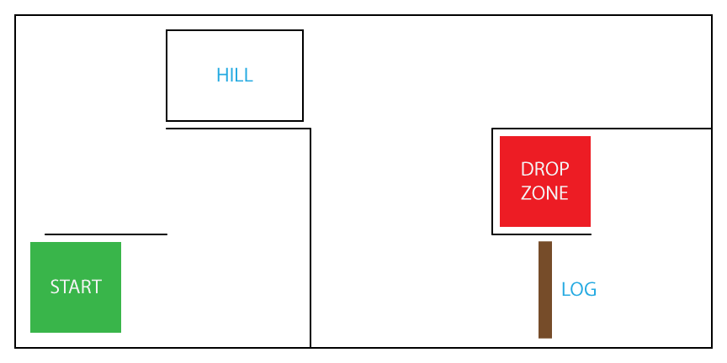

Teacher reflection
With this lesson/project, how are my students coming to an understanding of the following Big Ideas?
- User needs and interests drive the design process.
- Social, ethical, and sustainability considerations influence design.
- Complex tasks require different technologies and tools at different stages.
What could I improve on? What should I do differently next time?

Student handout: Designing an autonomous robot

Problem Scenario
In recent years British Columbia has experienced dry summer conditions leading to an increase in the number of forest fires. Fighting forest fires requires ongoing delivery of equipment and supplies. Due to reduced visibility and challenging wind and weather conditions, it can be difficult and dangerous to deliver supplies to the firefighters on the ground.

Design challenge
Students will create a robot that can navigate, without any user input, through an operating field that contains obstacles. The robot must leave its starting point, navigate autonomously using sensors, and stop within the designated drop target at the ending point of the field.

Parameters
- The robot must perform the task autonomously.
- Students are not permitted to interact with the robot while evaluation is taking place.

Required materials for robot
- chassis materials
- motors and motor controllers
- onboard computer/controller
- wires, cables, and cable ties
- screws and fasteners
- sensors (touch/bump, colour, distance, ultrasonic, gyro)
- assembly tools
- PC with required programming software

Success determinants
- Creation of a clear map of the obstacle field, including measurements
- Design of a robot chassis based on the following constraints:
- must have no more than four wheels in any configuration or two tank tracks
- size restricted to (as defined by the teacher)
height ____________
width ____________
length ____________
- limit of ONE drive motor per wheel

Sensors (one or more of the following)
- touch/bump
- colour
- distance
- gyro
- one onboard battery
- no loose wires
- one motor or servo for the deployment of the supply payload

