Name Card Templates
Les vacances d’été (Summer Holidays)
Core French, Grade 9

Overview
During the first week of classes in September, students are given a nameplate template (attached) with some simple survival phrases and basic question words (e.g., Who? Why? How?).
This activity encourages classroom interaction and communication in French from the beginning of the year. The activity supports the goals of using French for self-expression and communicating effectively and authentically in French in the classroom.
Big Ideas | - Listening and viewing with intent strengthens our understanding and acquisition of French.  - We can have meaningful conversations about things that are important  to us in French.
Curricular Competencies | - Use a growing variety of strategies to increase understanding  - Seek clarification and provide verification of meaning through a variety  of strategies  - Participate in short and simple conversations  - Exchange ideas and information using complete sentences, orally and  in writing  - Ask and respond to questions on familiar topics  - Describe people, objects, places, and personal interests
Content | - An increasing range of commonly used vocabulary and sentence structures for conveying meaning:  - asking and responding to various types of questions  - Describing people, objects, places, and personal interests
Core Competencies | Communication:  - Connect and engage with others (to share and develop ideas)  - Acquire, interpret, and present information  Thinking:  - Generating ideas  - Developing ideas  Personal and Social:  - Self-determination

The Learning Experience
During the first week of classes in September, students were given a nameplate template (attached) with some simple survival phrases and basic question words (e.g., Who? Why? How?). Students were given 15–20 minutes to create a personalized nameplate illustrating the places they went and their activity or activities during the summer vacation.
Using a series of questioning techniques known as “circling,” the teacher held up a student’s name card and asked the class a series of questions in French:
“Where did [student’s name] go during the summer holidays?”
“What did [student’s name] do there during the holidays?”
As the class saw each drawing, they interpreted from the visual where and what the student did during the holidays, responding with the appropriate information in brief phrases or with more complete information. Throughout the questioning, the teacher was able to provide many repetitions of the past-tense structures necessary to communicate about the variety of activities that students engaged in, asking deeper questions, such as “with whom,” “for how long,” and so on, and exploring a variety of aspects of each student’s experience.
Throughout this process, all students in the class were able to share their experiences in a safe and supportive environment. Each student was acknowledged and a sense of community and trust was established as an important element of the learning environment for the school year.
The teacher was able to discuss the experiences of four or five students per lesson in depth. As a result of the process, students were able to communicate about their past experiences without having a formal grammar and or vocabulary lesson. At times, the teacher was able to invent a simple story about the student, as though the student were a character in a short class story. The teacher also brought in props to highlight or emphasize the different activities and to build vocabulary around each student’s responses. Students got to know their classmates early in the year and were able to identify activities and experiences associated with each one, thus contributing to important community building early in the year.
After each lesson, the teacher gave an informal True/False quiz (formative assessment) to see what students remembered about the students they had discussed each day.

Teacher Reflection
How does this material align with a “concept-based, competency-driven curriculum”?
Through questioning related to their personal activities and experiences, students learn to respond to one another’s interests as they develop their communicative and social/personal competencies. As they use French to share personal information in an authentic way, they develop a sense of belonging and community, using a new language to discover the relationship between language and culture.
How does this material support assessment for learning?
Students are able to enter the conversations at their own level, sharing information about themselves in an authentic way and using the level of language that they have at that particular point in time. Students may answer with one-word answers, short phrases, or more complex responses. Teachers can use formative assessment for interpersonal communication to assess the level and complexity of student responses.
As a further assessment activity, students could be asked to write a short article entitled “Les vacances d’été” for the French Class Bulletin, highlighting the experiences of three or four students in the class. They would be expected to use the key target structures and vocabulary that were acquired during the class activity and discussion.
First Peoples worldviews/First Peoples Principles of Learning
This activity supports stories shared through oral traditions. First Peoples’ views of learning are promoted through the sharing of personal stories and experiences orally, contributing to a sense of community and belonging.
As students share their personal stories, other students become aware of experiences and places that are connected as they learn about the world around them.
How does this material lend itself to modification and/or adaptation for struggling students, or students with special needs?
This material can be easily adapted for any level of learning. As students can participate at the level that is comfortable for them, all students have the opportunity to contribute to the activity.
What elements were most successful and least successful? Why? What elements would be altered for next time, and how?
One of the most successful elements of this activity is the sense of community and acknowledgement of personal experiences that grows from the classroom sharing. This contributes to a sense of self-worth and safety in students when taking risks to express their
point of view.
What advice might be offered to teachers who would like to try this out?
Teachers can use this activity to talk about any current topic or experience. The same activity can be used to talk about, for example, what they are afraid of, what they like to eat, or what they plan to do on the weekend.
Additional comments?
It is important to acknowledge each student’s card, giving each student time to be the focus of the attention or the “star” of the class.

Some Sample Student Nameplates

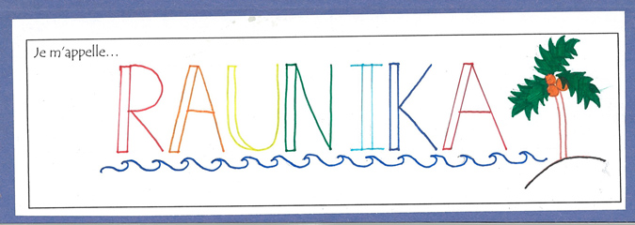

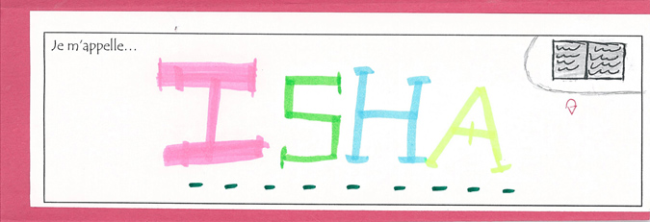

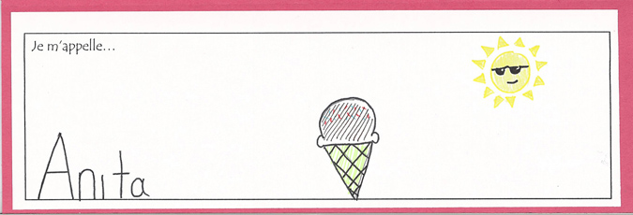

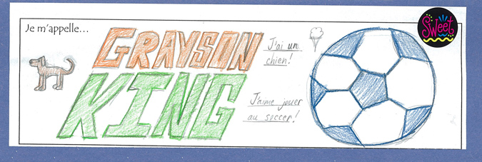

A Nameplate Template

Je m’appelle…

Phrases utiles
Je ne comprends pas. | I don’t understand |  | Quand? | When?
Répétez s’il vous plait. | Please repeat. |  | Où? | Where?
Comment dit-on…? | How do you say…? |  | Pourquoi? | Why?
S’il vous plaît | Please |  | Comment? | How/what is it like?
Merci | Thank you |  | Combien? | How many?
Est-ce que…? | Is it that… |  | Quel(le)? | Which/what?
Qui? | Who? |  | Avec qui? | With whom?
Qu’est-ce que? | What?

