“Injustice” by Allison Wall
English Language Arts, Grade 9
Inquiry question: How does an individual address injustice in society?
Abstract
This sample highlights my thinking and planning as it relates to a poetry lesson based on the redesigned BC Curriculum. I have made explicit connections to the First Peoples Principles of Learning, the Big Ideas, the Curricular Competencies and Content learning standards, Core Competencies, and. I have deliberately chosen activities that offer opportunities for multiple entry points, choice, and differentiation. I have also included some samples of student work.
Through the exploration of text, discussion, and the activities of the lesson, students have opportunities to respond to the inquiry question with an informed and thoughtful voice.
As students engage with text, collaborate with one another, create personal responses to text, and finally reflect on the process of their learning, they are doing so purposefully, considering the inquiry question.
Student learning depends on considering prior knowledge, sharing and developing ideas, and revising and extending thinking. A previous lesson examined poetry and songs addressing residential schools and other injustices endured by the First People of Canada.
First Peoples Principles of Learning
“Exploring stories and other texts helps us understand ourselves and make connections to others and to the world.” (Big Idea, English Language Arts, Grade 9)
This statement is echoed by the First Peoples Principle stating that “learning ultimately supports the well-being of the self, the family, the community, the land, the spirits, and the ancestors,” that “learning is holistic, reflexive, reflective, experiential, and relational (focused on connectedness, on reciprocal relationships, and a sense of place)” and, finally, that “learning requires exploration of one’s identity.”
The Big Ideas
- Exploring stories and other texts helps us understand ourselves and make connections to others and to the world.
- People understand text differently depending on their worldviews and perspectives.
- Texts are socially, culturally, and historically constructed.
- Questioning what we hear, read, and view contributes to our ability to be educated and engaged citizens.
Curricular Competencies
- Think critically, creatively, and reflectively to explore ideas within, between, and beyond texts
- Construct meaningful personal connections between self, text, and world
- Respond to text in personal, creative, and critical ways
- Use writing and design processes to plan, develop, and create engaging and meaningful literary and informational texts for a variety of purposes and audiences
Content
- Strategies and processes:
  - Writing processes
Core Competencies
The Learning Experience
Exploring the concept of injustice
Students are invited to bring to class examples of injustice in our community and/or in our world. This provides multiple entry points into the inquiry for the students.
- These examples provide opportunities for students to discuss the diverse ways in which injustice is evident/experienced in their own lives.
Here is a possible starting point for the progression of assessment. Throughout this lesson you will have opportunities to observe, ask questions, and provide feedback to students.
Compare and contrast
Students are challenged to contrast the tone/attitude of two poems. I chose “Remember” by Jacqueline Oker and “I Lost My Talk” by Rita Joe, but you could choose any two poems with different tones.
- I hope students come to recognize through the reading and exploration of the two poems that there is a difference in the tone.
- Students need to elaborate on why they believe there is a difference in tone.
Ask students to consider various ways in which they could analyze the tone of the poems.
- I’ve chosen to ask students to circle or highlight the strong verbs that create the tone of each poem, then to divide into think-pair-share and discuss their words.
- You might ask your students to write these powerful verbs on the whiteboard or sticky notes and have them discuss their words as a larger group.
Provide the students with an opportunity to synthesize their analysis of the poems.
- I’ve chosen to provide a structured worksheet to help scaffold my students’ thinking processes.
- Some students may choose to represent their analysis through words and images.
- I often use Venn diagrams and t-charts as pre-writing activities to generate ideas (this could be done independently, in pairs, or as a class).
Students synthesize their understanding of the two poems by writing a structured, thesis statement.
Blackout poetry
Students engage in a creative and critical activity, creating blackout poetry, imitating appropriation by repurposing a poem with a negative tone to create one with a positive tone.
- Explain the ideas of language appropriation and reclamation
- Students are each given a page from “The Indian Potlatch,” by Rev. J.B. McCullagh
- The page comes from a text that supported the Potlatch Law, legislation forbidding the practice of the potlatch passed by the government of the Dominion of Canada in 1885.
- Students create a blackout poem by selecting words and phrases on the page, removing them from their original context, and linking them together to create a new, positive message in a found poem format.
Blackout poem, student sample
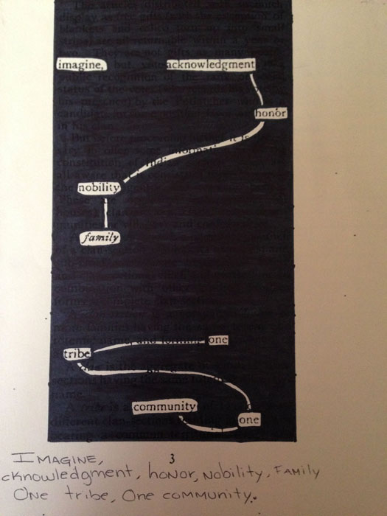 | Modification and/or adaptation  Students who typically struggle in the ELA classroom often find success in this lesson. To create the blackout poem, they do not have to come up with their own words, as the vocabulary is provided, nor do they have to follow grammatical conventions. Additionally, they are willing to take risks with language without foreseeing the end result. Academic students, on the other hand, can feel anxious about the uncertainty of the process of writing the blackout poetry.
Each student writes his or her new poem in the margin of the found poem, abiding by the line breaks in the found poem format. Whatever is linked in the blackout version is one line. Breaks in the blackout represent line breaks in the poem. This helps with the clarity of their text when reading and makes students consider where ideas begin and end and where line breaks are suitable.
Empathy journal
Afterwards, students respond to the activity in their empathy journals, describing the metaphor of the activity.
The purpose of the student empathy journal is:
- to make a positive from a negative
- to recognize that what is done can’t be undone — the harsh words still show through the black marker, just as the injuries of residential schools left emotional and psychological scars that won’t completely disappear
The following text, called “Friendship Nails,” addresses these concepts. The analogy might help students connect with the Personal Awareness and Responsibility Core Competency as it relates to personal awareness and taking responsibility for their own choices and actions.
Friendship Nails
There once was a little boy who had a bad temper. His father gave him a bag of nails and told him that every time he lost his temper, he must hammer a nail into the back of the fence. The first day the boy had driven 37 nails into the fence. Over the next few weeks, as he learned to control his anger, the number of nails hammered daily gradually dwindled down. He discovered it was easier to hold his temper than to drive those nails into the fence.
Finally the day came when the boy didn’t lose his temper at all. He told his father about it and the father suggested that the boy now pull out one nail for each day that he was able to hold his temper. The days passed and the young boy was finally able to tell his father that all the nails were gone.
The father took his son by the hand and led him to the fence. He said, “You have done well, my son, but look at the holes in the fence. The fence will never be the same. When you say things in anger, they leave a scar just like this one. You can put a knife in a man and draw it out. It won’t matter how many times you say I’m sorry, the wound is still there.”
— Author unknown

Empathy journal, student sample
Student responses are a useful assessment tool to ensure that the Big Ideas addressed by the lesson are understood.
Assessment considerations
Student assessment focused on the following:
Feedback: I provided descriptive feedback during the class discussion and think-pair-share activities. I circulated around the room, observing, and asking questions while students drafted their blackout poetry.
Self and peer assessment: Students adjusted and extended their thinking in response to discussions with peers and the teacher; they revised and edited their writing to make improvements.
Metacognition: Students reflected on their learning and documented their thoughts and understandings in their empathy journals.
Teacher reflection
Looking back on the lesson, students engaged emotionally and intellectually in learning about social injustices of recent history and today. They experienced shock, compassion, and empowerment.
Modelling the process of creating the blackout poetry and sharing samples was critical
to the learning experience. Consider drafting part of a blackout poem together, using a document camera, projector, and Smart Board. Without initial support and clarity of task, students are easily confused, because the process of writing the found poetry/blackout poetry is not linear or obvious, but organic and experimental.

