Circles and Patterns Math Provocation

Through open-ended provocations, Louesa Byrne’s Kindergarten students at Thompson Elementary are invited to use curricular competencies to investigate and uncover mathematical concepts. Provocations often begin with an inquiry question, merging students’ interests and curriculum content. In this example, near the end of the school year, students are bringing together two familiar ideas – patterns and shapes.

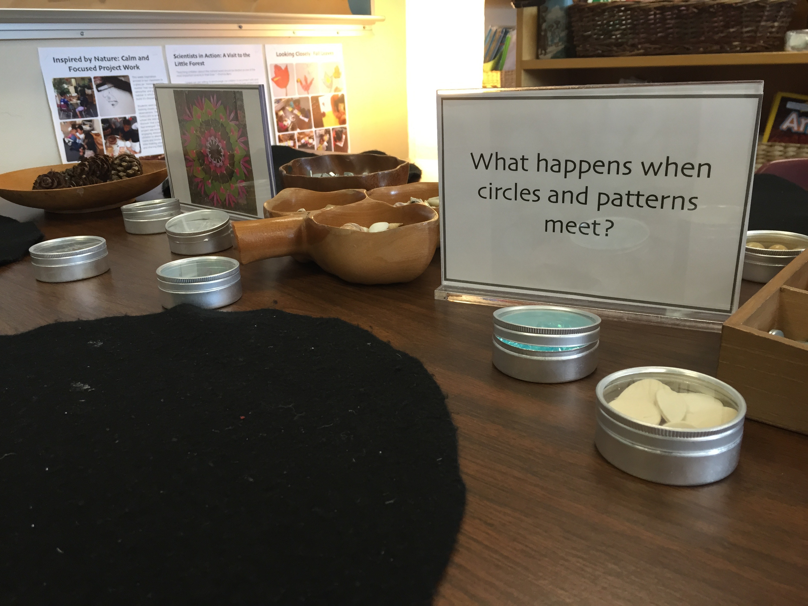
By intentionally choosing materials to inspire their mathematical thinking, Louesa is guiding their investigation yet there are many choices available for students to personalize the task. Using a variety of materials, including those found in the local natural environment, provides opportunities for students to think about patterns and shapes in different ways. The students embedded repeating patterns within radiating, spiral and circular patterns.
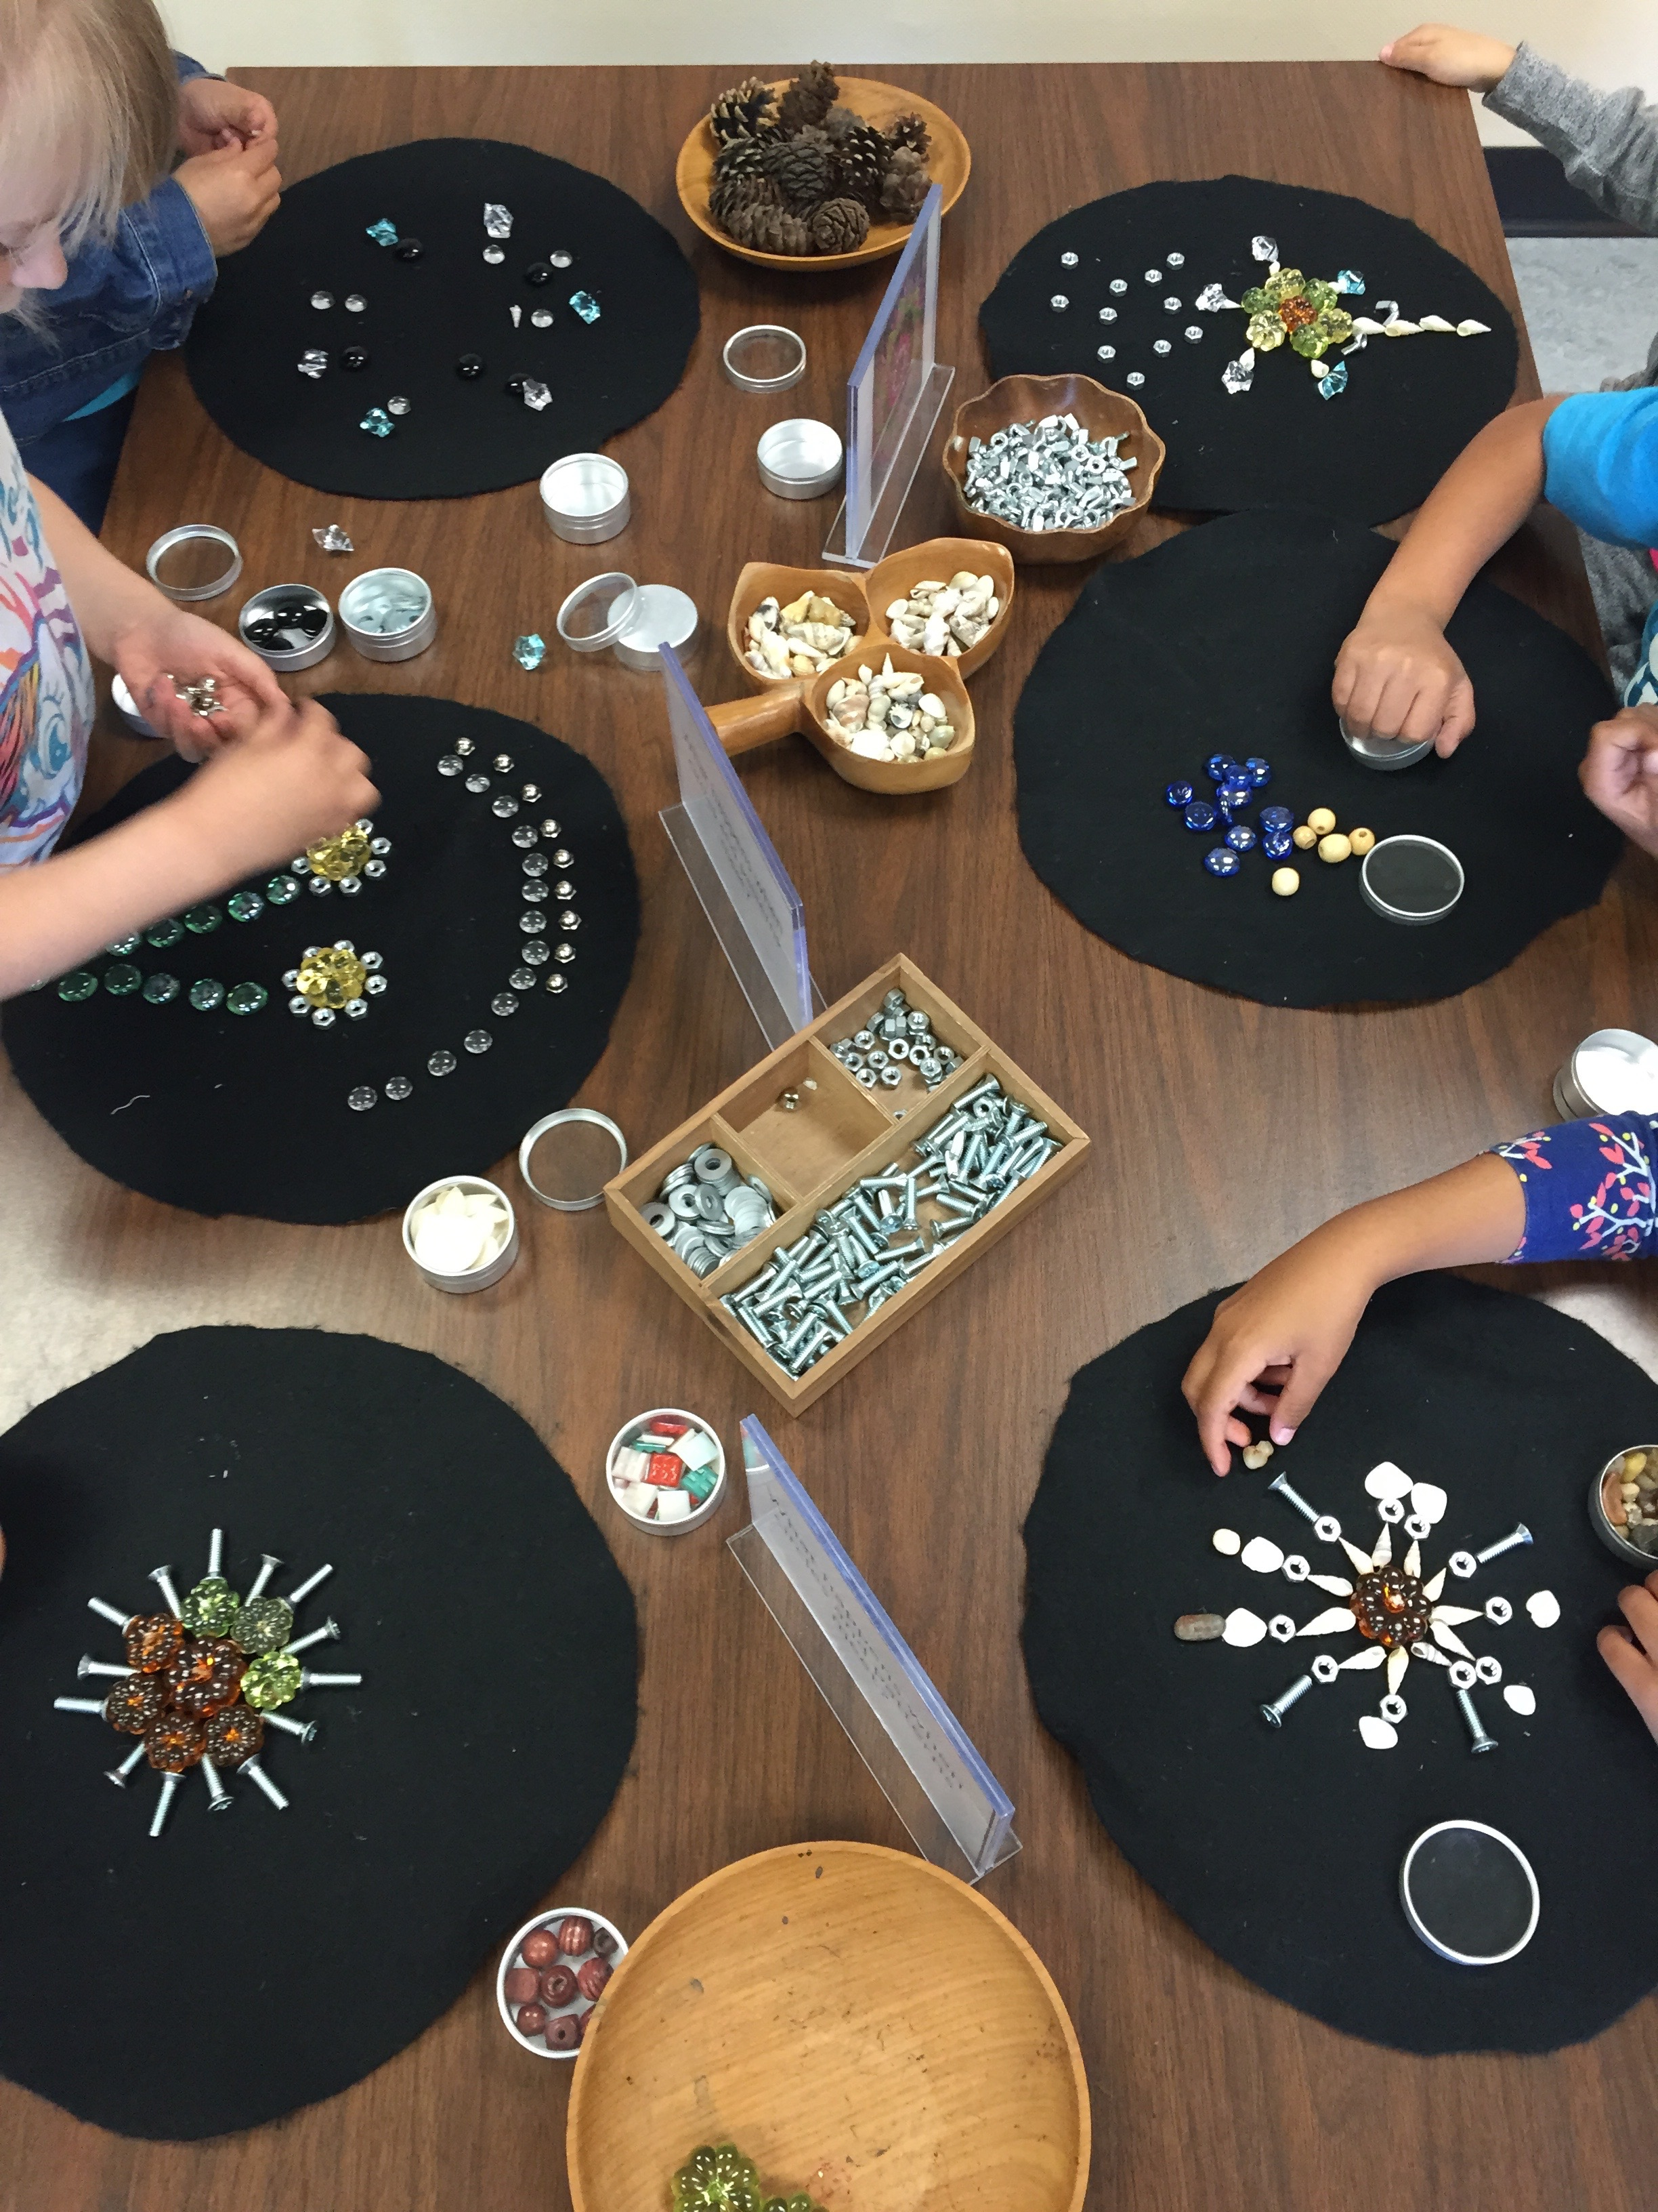
The students naturally began to collaborate together and discuss what they were doing with the materials and develop ideas together. Clipboards with paper on them are provided for students to record a representation of what they have created. As the classroom teacher, Louesa takes photographs and video recordings as a way to capture the students’ thinking and learning along with listening to the students and asking them questions to elicit their thinking.
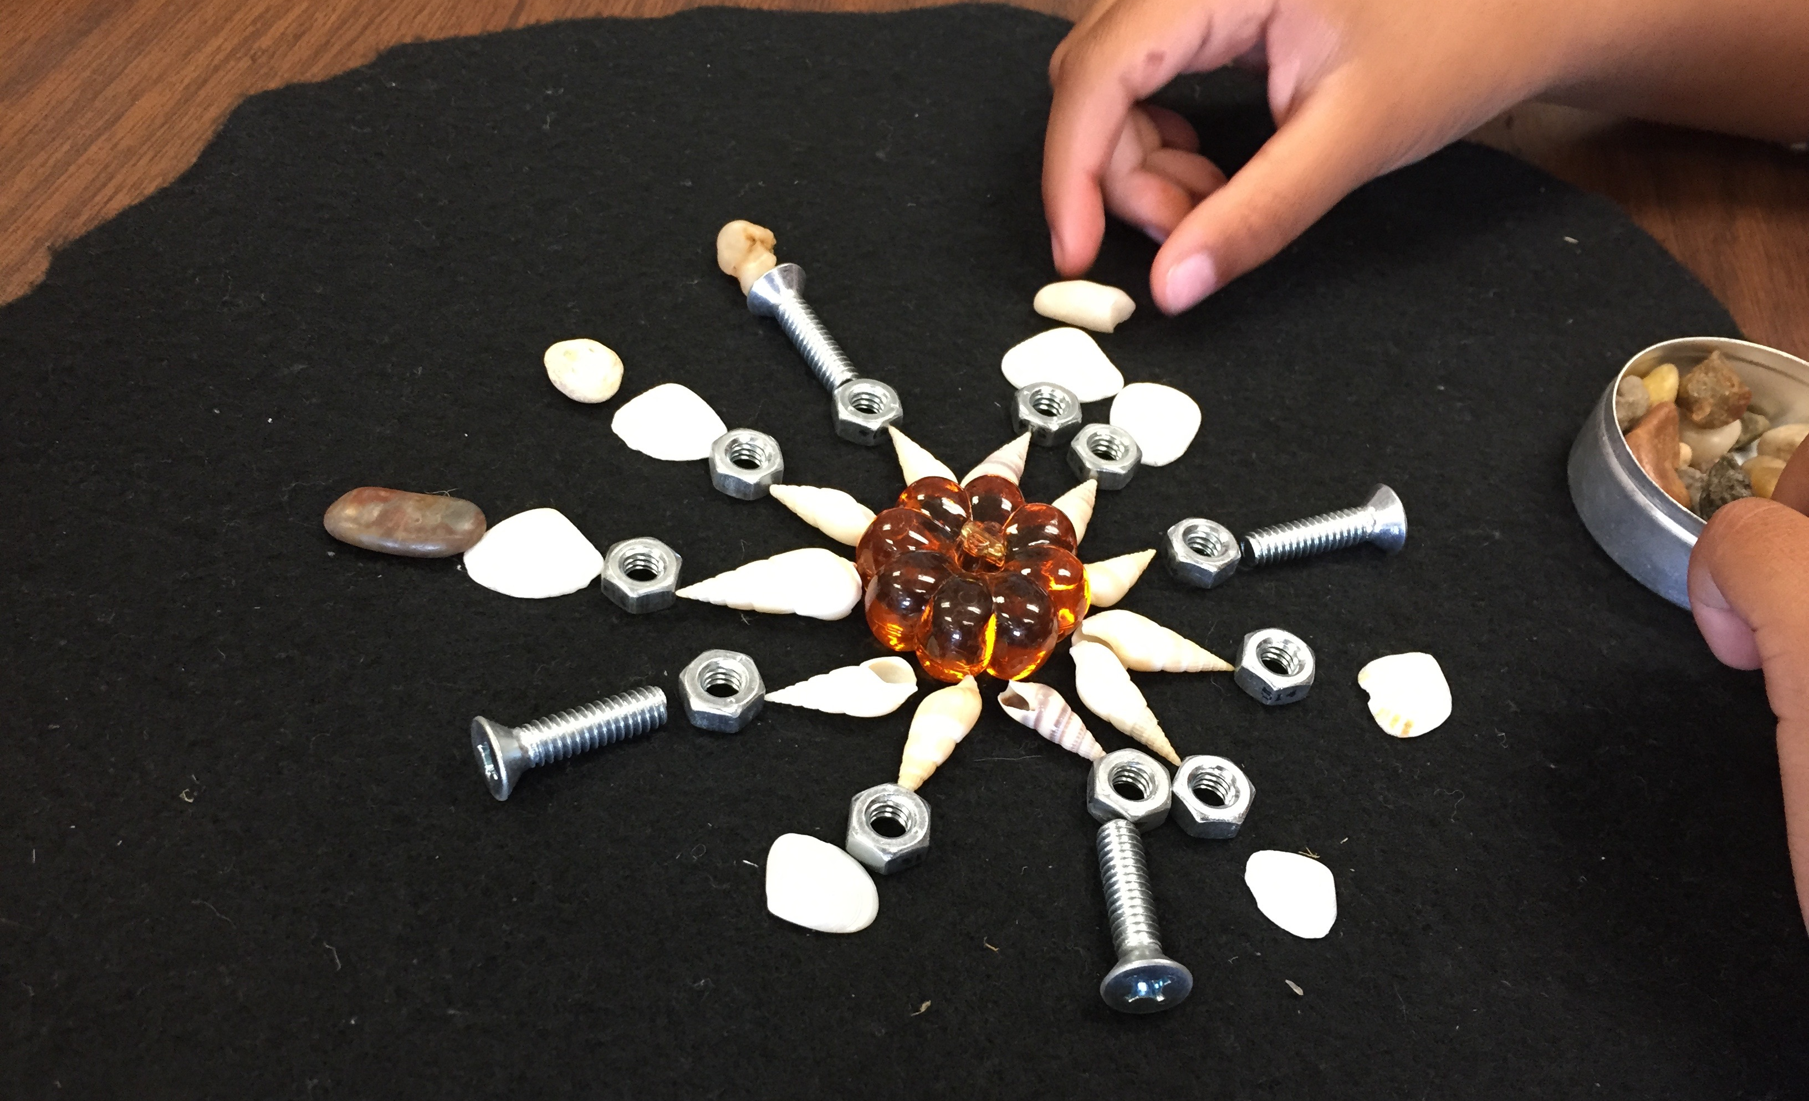

Core Competencies: Communication (connect and engage with others to share and develop ideas), Creative Thinking (generating and developing ideas)
Big Ideas: Repeating elements in patterns can be identified. Objects have attributes that can be described, measured, and compared. (Mathematics)
Inquiry Question: What happens when circles and patterns meet?
Curricular Competencies: use reasoning and logic to explore and make connections; develop, construct, and apply mathematical understanding through role-play, inquiry, and problem solving; communicate in many ways; describe, create, and interpret relationships through concrete, pictorial, and symbolic representations; visualize and describe mathematical concepts; connect mathematical concepts to each other and make mathematical connections to the real world (Mathematics)
Curricular Content: repeating patterns with two or three elements, single attributes of 2D shapes and 3D objects (Mathematics)

